**DWDM**

**Lab Worksheet 4**

18BCS004

(R.Jimrin Fernando)

Naive Bayes Classification

1. For the given dataset, apply naïve bayes classifier to build model and predict class label for the test set (Overcast, Mild), (Sunny, Cool), (Rainy, Hot) using python scikit.

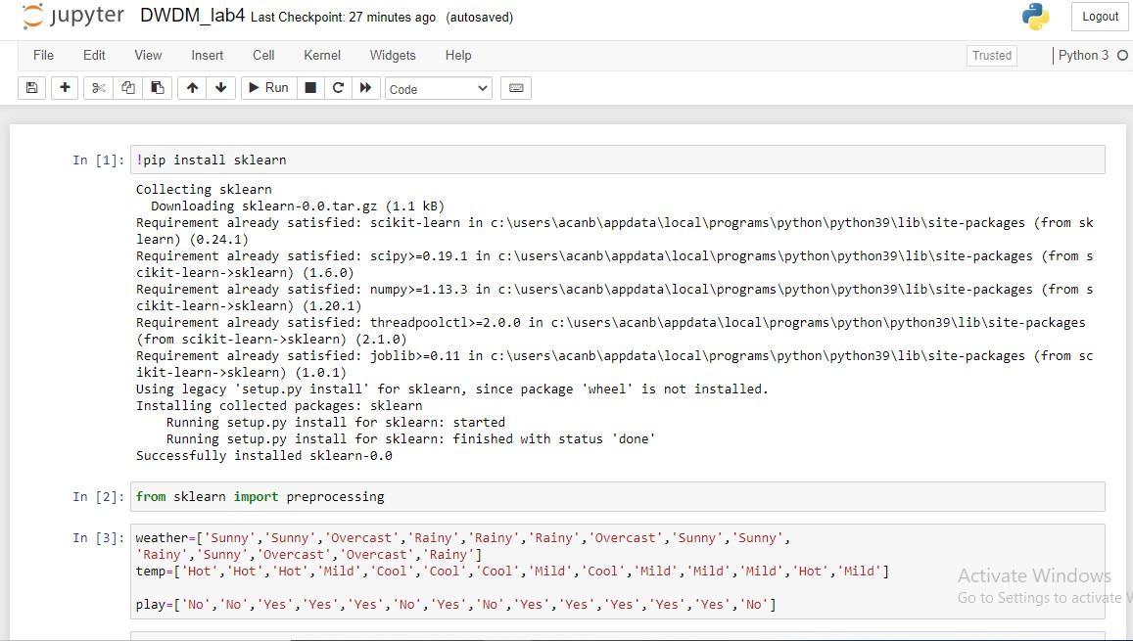

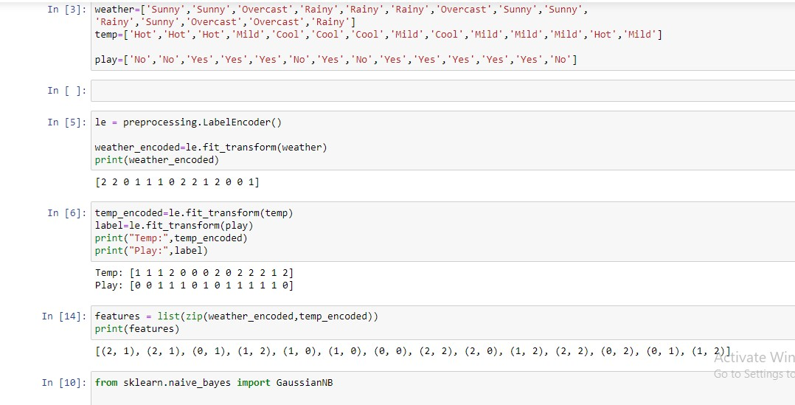

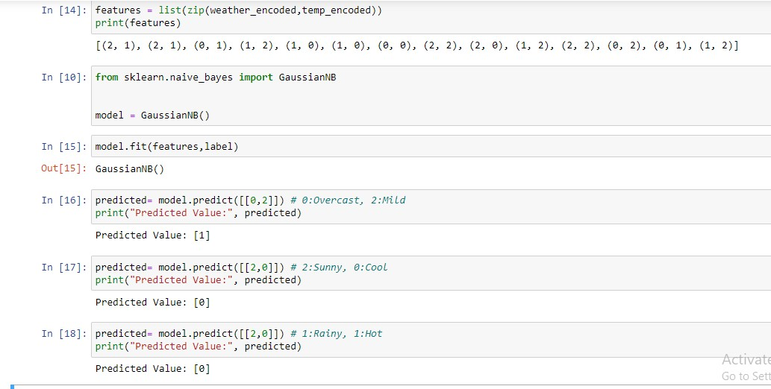

1. Download “pima-indians-diabetes.csv” dataset. Load thedataset and implement Naïve Bayes Classification algorithm using python. Divide the dataset to Training set and testing set. Calculate probabilities and build prediction model. Print the Prediction for Test set and accuracy.

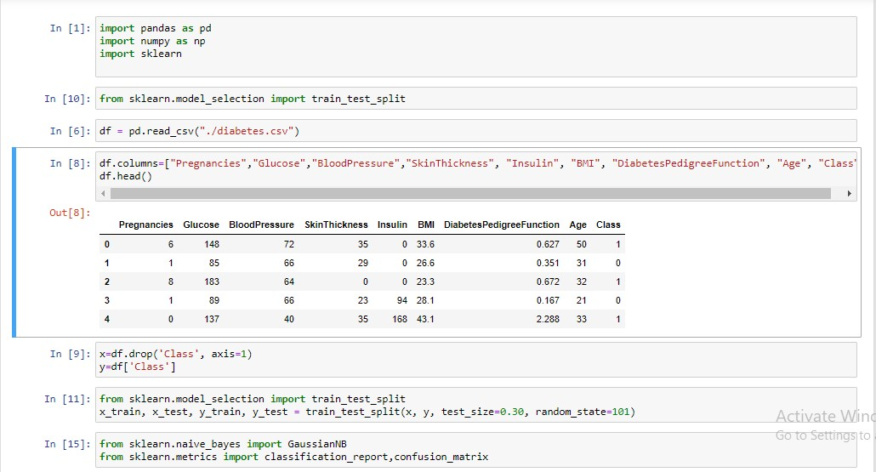

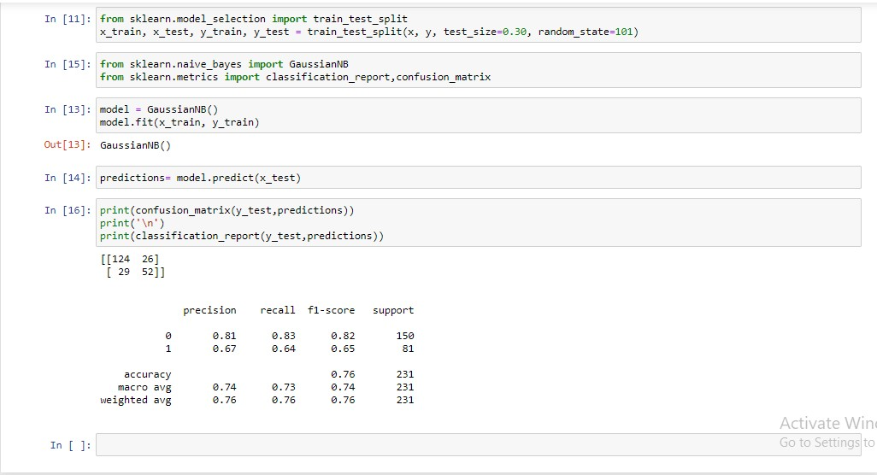

1. Download “iris.csv” dataset. Apply Gaussian Naïve BayesModel for prediction. Print the classification report and confusion matrix. Write a short inference from the result.

